

Sri Lanka Institute of Information Technology

Research Expert Pooling and Management
System
Software Requirement Specification

Information Systems Project 2025

Project ID: 2025_S2_06

Submitted by:

Registration Number | Student Name
IT23720138 | M N Noora
IT23756496 | Gunathunga J L S
IT23681392 | Ruchirangani D M V

Submitted to:

(Supervisor’s signature)

…………………………..

Mrs Narmada Gamage

Date of submission
Table of Contents
Table of Contents i
Revision History ii
1. Introduction 1
1.1 Purpose 1
1.2 Document Conventions 1
1.3 Intended Audience and Reading Suggestions 3
1.4 Product Scope 5
1.5 References 6
2. Overall Description 7
2.1 Product Perspective 7
2.2 Product Functions 10
2.3 User Classes and Characteristics 11
2.4 Operating Environment 12
2.5 Design and Implementation Constraints 12
2.6 Project Documentation 13
2.7 User Documentation 15
2.8 Assumptions and Dependencies 16
3. External Interface Requirements 17
3.1 User Interfaces 17
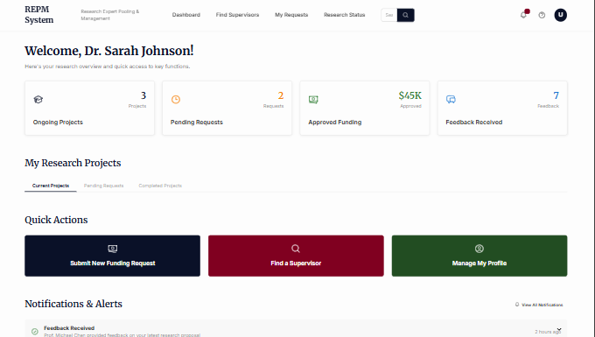 18
3.2 Hardware Interfaces 20
3.3 Software Interfaces 20
3.4 Communications Interfaces 20
4. System Features 21
4.1 System Feature 1 21
4.2 System Feature 2 26
4.3 System Feature 3 27
4.4 27
4.5 System Feature 3 (and so on) 27
5. Other Nonfunctional Requirements 49
5.1 Performance Requirements 49
5.2 Safety Requirements 50
5.3 Security Requirements 51
External Policies and Regulations 51
5.4 Software Quality Attributes 52
Availability 52
Correctness 52
Flexibility 52
Robustness 52
Usability 52
5.5 Business Rules 53
6. Other Requirements 54
6.1 Database Requirements 54
6.2 Legal Requirements 54
Appendix A: Glossary 55
Appendix B: Analysis Models 57
Appendix C: To Be Determined List 57

Revision History
Name | Date | Reason For Changes | Version

Introduction

Purpose
This Software Requirements Specification (SRS) document defines the requirements for the Research Expert Pooling and Management System, a web-based application developed for the Ministry of Science and Technology in Sri Lanka, version 1.0. The system is designed to simplify and enhance the coordination, management, and monitoring of national research activities by providing an integrated solution for supervisor-researcher coordination, research categorization, funding, and progress tracking.
The extent of this SRS includes the entire Research Expert Pooling and Management System and all its subsystems and main features. These include the Supervisor and Feedback Management module, the Research Handling and Assignment Engine, and the Ministry Interface and System Oversight module. The system facilitates secure registration of supervisors, researchers, and research institutions; auto-classification of research and expertise by fields (e.g., Science, Health, Engineering); manual selection of supervisor with confirmation of availability; real-time tracking of progress; step-by-step workflows for requesting funding; and a centralized Ministry dashboard for monitoring and analytics. The SRS prescribes the non-functional and functional needs of these institutions to ensure the system enables efficient collaboration, openness, and decision-making based on facts to bolster Sri Lanka's research infrastructure. This SRS describe the whole system.

Document Conventions
The SRS follows the IEEE 830-1998 standard for Software Requirements Specifications, ensuring a structured format with clear sections for purpose, scope, functional and non-functional requirements, and other relevant components.
All sections are numbered sequentially (e.g., 1.1, 2.1) for easy reference and navigation.
Headings are organized hierarchically, with main sections in bold and larger font sizes (e.g., 1.1 Purpose) and subsections in smaller headings for clarity.
Table 1.1 Typographical conventions in SRS
Typographical Conventions | Purpose
Bold Text | - Used for section headings (e.g., Purpose, Functional Requirements)  - To emphasize key terms or module names (e.g., Supervisor and Feedback Management).
Italic Text | - Used to denote references to external documents, standards (e.g., IEEE 830-1998), or specific tools and technologies (e.g., PostgreSQL, Figma).
Monospace Font | - Used for technical terms, such as specific database fields, API endpoints, or code-related terms (e.g., supervisor_id, POST /register).
Bulleted and Numbered Lists | - Used to clearly delineate multiple requirements, features, or steps within a section for readability.
Tables | - Used to present structured data, such as functional and non-functional requirements, with consistent column headers in bold and aligned text for clarity.
Font and Formatting | - The document uses a consistent font, Times New Roman, with a size of 12 pt for body text and 18 pt for main headings, ensuring readability.  - Subheadings use 14 pt bold for distinction, while body text remains in regular style.  - Hyperlinks to external references (e.g., https://www.researchexpert.org/2025820_32870721.pdf) are underlined and clickable for easy access.  - Consistent spacing (1.15 line spacing) and margins (1-inch all sides) are maintained throughout the document.

Intended Audience and Reading Suggestions
Table 1.2 Intended Audience
Chapter | Section | Intended Audience | Purpose
1. Introduction | - Purpose  - Document Conventions  - Intended Audience  - Product Scope  - References | Developer  Project Manager  Tester  Ministry of Science and Technology [1.4] | To understand the system’s purpose and scope.  To grasp the project’s purpose and scope.  For context and document conventions.  To understand the system’s goals and benefits.
2. Overall Description | - Product Perspective  - Product Functions  - User Classes and Characteristics  - Operating Environment  - Design and Implementation Constraints  - Project Documentation  - User Documentation  - Assumptions and Dependencies | Developer  Project Manager  Tester  Ministry of Science and Technology | For context, product functions, and constraints.  To understand constraints, assumptions, and project documentation requirements.  To understand user classes and operating environment.
3. External Interface Requirements | - User Interfaces  - Hardware Interfaces  - Software Interfaces  - Communications Interfaces | Developer | For technical details on interfaces
4. System Features | - System Feature 1  - System Feature 2  - System Feature 3 | Developer  Project Manager  Tester | For detailed functional requirements.  To align development tasks with project milestones.  For testable functional requirements.
5. Other Nonfunctional Requirements | - Performance Requirements  - Safety Requirements  - Security Requirements  - Software Quality Attributes  - Business Rules | Developer  Project Manager  Tester | For performance, security, and quality expectations.  For constraints impacting timelines or resources.  For performance, security, and quality metrics to design test cases.
6. Other Requirements

Appendices |  | Developer | For UML diagrams to guide implementation

Product Scope
Research Expert Pooling and Management System is a web application developed for the Ministry of Science and Technology in Sri Lanka to coordinate and manage national research. The primary aim of the system is to enhance the effectiveness, transparency, and coordination of research activities by providing a centralized system for supervisor-researcher coordination, research categorization, funding, and monitoring of progress in real time. The system provides secured registration of researchers, supervisors, and institutes, manual supervisor selection with availability checking, automates shortlisting by categories on the basis of domains (Health, Science, Engineering, etc.), and provides a Ministry dashboard for governance based on data.

Its main benefits include simplified coordination, increased transparency through real-time monitoring, precise matching of expertise, easier funding procedures, and better collaboration among stakeholders. The objectives are to automate manual processes, reduce delays, ensure fair distribution of resources, and enable data-driven decision-making. The system is aligned with the strategic priority areas of the government in stimulating innovation, fostering interdisciplinary research, and developing Sri Lanka's research infrastructure for national development and global competitiveness.

References
[1]
“Lucid visual collaboration suite: Log in,” Lucid.app, 2015. https://lucid.app/lucidchart/a364e5c0-77a3-403b-9041-15ea1ce48edb/edit?invitationId=inv_64ff224d-ed68-40e0-b8bb-861295b39734&page=HWEp-vi-RSFO# (accessed Aug. 31, 2025).

[2]
“AI-powered Web & App Design,” Sketchflow.ai, 2025. https://www.sketchflow.ai/?gad_source=1&gad_campaignid=22743108843&gbraid=0AAAAA_4JxJVJfUP9tSMSOEUnyhtAiwQdi&gclid=Cj0KCQjw5c_FBhDJARIsAIcmHK-stdhOGDsEL1QEz_E2oXvEhb2WWcCs4xt8TstrBFtSXRleIdvdFJAaAgNXEALw_wcB (accessed Aug. 31, 2025).

[3]
Kirill Fakhroutdinov, “UML 2.4 Diagrams Overview,” Uml-diagrams.org, 2016. http://www.uml-diagrams.org/uml-24-diagrams.html (accessed Aug. 31, 2025).

[4]
Kirill Fakhroutdinov, “Use case diagrams are UML diagrams describing units of useful functionality (use cases) performed by a system in collaboration with external users (actors).,” Uml-diagrams.org, Aug. 05, 2010. http://www.uml-diagrams.org/use-case-diagrams.html (accessed Aug. 31, 2025).

Overall Description

Product Perspective
The Research Expert Pooling and Management System (REPM System) is a web-based subsystem developed to improve the Ministry of Science and Technology's fragmented processes for research supervision, expert allocation, and funding management. Currently, the Ministry relies on fragmented manual processes to manage research activities, leading to inefficiencies, delays, and a lack of centralized oversight.
This product is not an extension of an existing software family, but a new, specialized solution that integrates with the Ministry's larger research management ecosystem. Its primary role is to handle supervisor–researcher coordination, research domain categorization, structured funding workflows, and transparent progress monitoring.
The REPM System will interface with the national research database to validate researchers and projects, ensuring that only authorized individuals and institutes with pre-existing research records can register. In the long term, this subsystem will operate as a core module within the broader Ministry research management infrastructure, enhancing its functionality and supporting nationwide research governance.
System Architecture
The system is composed of three key modules:
- Supervisor (Academic) Module – Secure registration and verification, domain categorization, acceptance/rejection of supervision requests, feedback provision, workload management, and validation of funding requests before Ministry review.
- Researcher/Institute Module – Registration and profile management, supervisor selection with availability checking, supervision requests, submission of funding requests, and viewing of feedback and research status.
- Ministry/Admin Module – Centralized oversight via a real-time dashboard, monitoring of supervisor workloads and research progress, approval/rejection of registrations, funding allocation, analytics and reporting, and removal of inactive users.
External Interfaces
External interfaces include:
- Supervisors – validate requests, supervise projects, and provide feedback
- Researchers & Institutes – submit supervision requests, funding requests, and receive feedback
- Ministry/Admin – manages oversight, funding, registrations, and policies
- Existing Research Database – provides validation for researchers and projects, ensuring data consistency and preventing unauthorized access
System Workflows
At the core, the REPM System enforces structured workflows:
- Researchers submit supervision and funding requests through standardized forms
- Supervisors validate and manage requests while maintaining fair workload distribution with automatic capacity monitoring
- The Ministry oversees and approves validated requests, while ensuring policy compliance through centralized dashboard controls
System Positioning
Thus, the system serves as a central hub for research coordination, directly addressing inefficiencies, unauthorized access, workload imbalances, and lack of transparency in the current manual system. The REPM System transforms disconnected processes into an integrated, automated workflow that enhances collaboration, accountability, and strategic decision-making across Sri Lanka's research ecosystem.

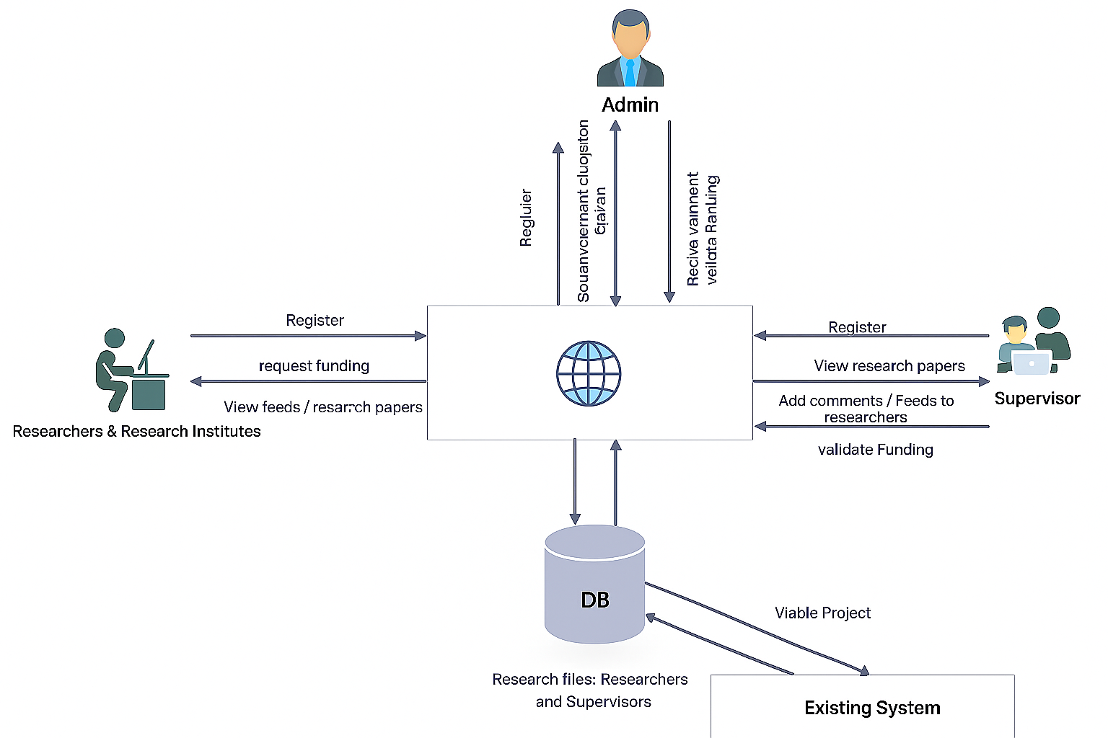

Figure 2.1 High Level Architecture Diagram

Product Functions
The system’s major capabilities are organized into four modules:
A. Researcher & Institute Module
- Secure registration for only eligible researchers/institutes whose works already exist in the national research database; unauthorized parties are blocked.
- View own registered research works and manage profile details.
- Manually select a preferred supervisor, check their availability (capacity), and submit a supervision request.
- Receive system-suggested alternative supervisors from the same domain when the preferred one is unavailable.
- Initiate structured funding requests that follow the validation/approval workflow.
B. Supervisor Module
- Secure registration and verification of academic supervisors; automatic categorization by domain (e.g., Health, Science, Engineering).
- Accept/reject supervision requests; system enforces maximum supervision capacity and marks supervisors “unavailable” when limits are reached.
- View all research in their specialization but give feedback/comments only on projects to which they’re assigned.
- Validate funding requests before forwarding to the Ministry.
- Update profile or remove themselves from the platform.
C. Ministry Oversight & Funding Module
- Central dashboard for end-to-end visibility (registrations, supervision assignments, workloads, progress, and funding status).
- Govern supervision workflows, ensure policy compliance, remove inactive users, and approve validated funding requests.
- Maintain detailed funding records, reporting, and analytics to support data-driven decisions.
D. Platform Services (Cross-Cutting)
- Role-based access control and secure workflows; integration with existing research databases.
- Centralized data store for users, research works, supervision requests, feedback, funding records, and activity logs.

User Classes and Characteristics
1) Ministry (Admin/Oversight users) — Primary/most critical to satisfy
- Responsibilities: System governance, policy compliance, supervision workflow oversight, funding approvals, user lifecycle (e.g., removing inactive accounts), analytics/reporting.
- Usage pattern: Frequent; dashboard-driven monitoring and decision making.
- Expertise: Moderate technical proficiency; high domain/policy expertise; high privilege level.
2) Supervisors (Verified academics) — Primary
- Responsibilities: Register and verify credentials, manage supervision capacity, accept/reject supervision requests, give structured feedback on assigned projects, validate funding requests.
- Usage pattern: Frequent to regular; interacts with queue of requests and assigned projects.
- Expertise: Moderate technical proficiency; subject-matter expertise; medium privilege.
3) Researchers & Research Institutes — Primary
- Responsibilities: Register (only if pre-existing works are in the national database), manage profiles, submit supervision requests, request funding, track progress/decisions.
- Usage pattern: Regular; task-oriented interactions for requests and updates.
- Expertise: Basic to moderate technical proficiency; low-to-medium privilege.
Note: “Guests/unauthorized users” are intentionally excluded—registrations are restricted to verified parties to protect integrity.

Operating Environment
Client (runtime):
- Web-based access via modern browsers (Chrome, Firefox, Edge); no local installation required.
- Typical user hardware: standard PC/laptop or tablet; ≥4 GB RAM, dual-core CPU; stable internet connection.
Server/Backend (development & deployment):
- Web stack: PHP backend; HTML/CSS/JavaScript frontend.
- Application server: Apache or Nginx; database server: PostgreSQL.
- Local development: XAMPP/WAMP or Docker; IDEs such as VS Code/PhpStorm; version control via Git/GitHub; testing with PHPUnit/Postman.
- Developer machines: ≥8 GB RAM, quad-core CPU; local server setup and backup storage for testing/version control.

Design and Implementation Constraints
- Technology stack is fixed: Frontend (HTML/CSS/JS), backend (PHP), PostgreSQL database, Apache/Nginx web server; Git/GitHub for VCS; Figma for UI/UX; PHPUnit/Postman for testing-limiting alternative language/framework choices.
- Integration constraint: Must interoperate with the existing national research database; registration permitted only for entities with pre-recorded works-constrains onboarding and requires data-matching/validation flows.
- Security & access model: Role-based workflows and verified/authorized participation only; supervisors validated at registration; supervisors can act only on assigned projects; strict enforcement of supervision capacity, these policies constrain UX and data access patterns.
- Process/policy constraints: Funding must follow a three-step workflow (researcher submission → supervisor validation → Ministry approval), and the Ministry retains authority to remove inactive users constrains state transitions and requires auditability.
- Data governance & transparency: Central dashboard, analytics, detailed funding records, and activity logs are required imposes logging/reporting overhead and schema considerations.
- Project schedule & budget: Delivery within 14 weeks and a budget of LKR 106,000 define scope, tooling, and hosting choices.
- Operational environment: Client is browser-only; runtime hardware as specified; local dev via XAMPP/WAMP or Docker—limits use of native clients and dictates web-first design.

Project Documentation
The Research Expert Pooling and Management System will be delivered with a comprehensive documentation package to ensure successful implementation, maintenance, and user adoption. The following documentation components will be provided:
Core Documentation Deliverables
1. System Requirements Specification (SRS)
- Format: IEEE 830-1998 standard compliant document
- Content: Complete functional and non-functional requirements, system constraints, and acceptance criteria
- Delivery: PDF and editable Word formats
2. System Design Document (SDD)
- Format: Structured technical documentation with UML diagrams
- Content: Detailed system architecture, database schema, API specifications, and component interactions
- Delivery: PDF format with embedded diagrams and technical specifications
3. User Manual and Training Materials
- Format: Multi-format documentation package
- Components:
  - Administrator User Guide (PDF)
  - Researcher User Guide (PDF)
  - Supervisor User Guide (PDF)
  - Ministry Dashboard User Guide (PDF)
  - Video tutorials for key workflows (MP4 format)
- Content: Step-by-step operational procedures, troubleshooting guides, and best practices
4. Technical Documentation
- Format: Developer-focused documentation
- Components:
  - Installation and Deployment Guide (Markdown/PDF)
  - Database Administration Manual (PDF)
  - System Maintenance Guide (PDF)
  - API Documentation (HTML/PDF with interactive examples)
  - Code Documentation (Generated HTML from source code comments)
5. Testing Documentation
- Format: Quality assurance documentation package
- Components:
  - Test Plan Document (PDF)
  - Test Case Specifications (Excel/PDF)
  - Test Execution Reports (PDF)
  - User Acceptance Testing (UAT) Documentation (PDF)
6. Project Management Documentation
- Format: Project oversight and tracking documents
- Components:
  - Project Charter (PDF)
  - Work Breakdown Structure (PDF/Project file)
  - Risk Management Plan (PDF)
  - Change Management Log (Excel/PDF)

User Documentation
- A User Manual for researchers (how to register, request supervisors, submit funding requests).
- A Supervisor Guide (how to verify credentials, accept/deny requests, provide feedback).
- A Ministry User Guide (how to monitor progress, approve funding, access dashboard analytics).
- Online Help / FAQ inside the web system.
- Possibly tutorial videos or a step-by-step onboarding wizard for new users.

Assumptions and Dependencies
Assumptions
- The Ministry will adopt and support the system.
- Supervisors will regularly update their availability.
- Pre-registered research data will be provided in a usable format.
- Funding requests will follow standard formats.
Dependencies
- Availability of Ministry’s existing research databases for integration.
- Internet connectivity for system access (since it’s web-based).
- Secure hosting environment and SSL certificates.

External Interface Requirements

User Interfaces
- Researcher Dashboard → profile, supervisor request form, funding request form, project progress tracking.
- Supervisor Dashboard → supervisor profile, request approval/denial, feedback forms, project progress view.
- Ministry Dashboard → oversight panel with analytics, funding approvals, overall research project visibility.
- Admin Panel → user management, database monitoring, security control.
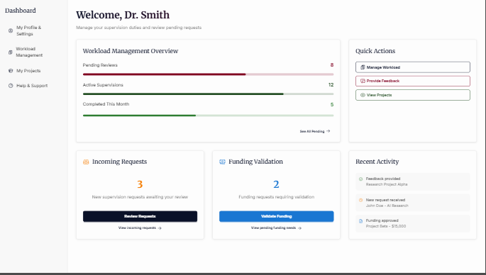

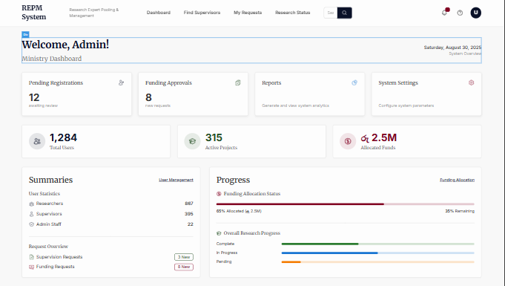

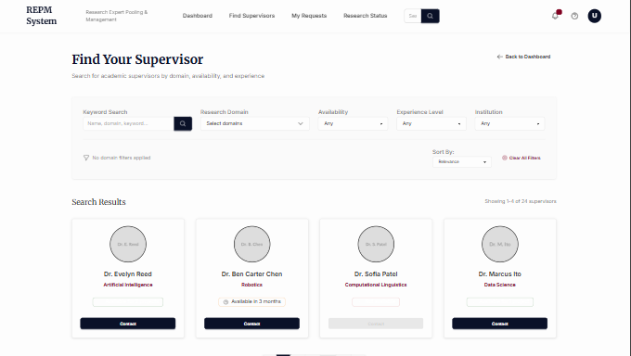

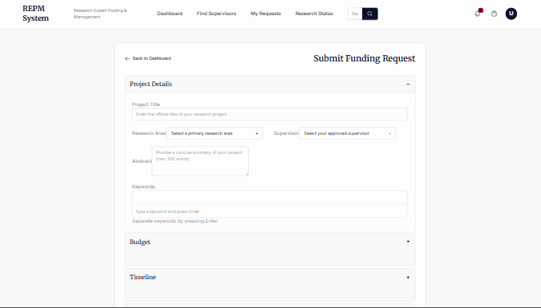

Hardware Interfaces

Software Interfaces
- Database: PostgreSQL.
- Backend: PHP framework.
- Frontend: HTML, CSS, JavaScript.
- Web Server: Apache/Nginx.
- Integration: APIs for existing research databases.
- Tools: GitHub (version control), Postman (API testing), PHPUnit (testing).

Communications Interfaces
Networking and communication standards.
- Protocols: HTTPS (for security).
- Access: Through web browsers (Chrome, Firefox, Edge).
- Encryption: SSL certificate for secure login and data transfer.
- Authentication: Role-based login (Researcher, Supervisor, Ministry, Admin)

System Features

System Feature 1
Supervisor

FR 1 | Supervisor Registration
Input | Registration details (Name, Email, Affiliation, Domain, Qualifications)
Process | System captures details and store in temporary database for verification
Output | Supervisor profile created (Pending verification)
Definition | Allow supervisors to securely register in the system

FR 2 | Supervisor Verification
Input | Registration details
Process | System cross-checks credentials with validation rules or Ministry data
Output | Verification status (approved or rejected)
Definition | Ensures only verified academic supervisors can access the system

FR 3 | Domain Categorization
Input | Supervisor specialization details
Process | System classifies supervisors into predefined categories (Health, Science, etc.)
Output | Categorized supervisor entry in database
Definition | Supervisors are grouped by expertise (Health, Science, etc.)

FR 4 | Feedback and Commenting System
Input | Supervisor feedback and comments on assigned projects
Process | System records feedbacks and comments, links it to the project, and updates researcher dashboard
Output | Stored feedback and comments visible to researcher and Ministry
Definition | Supervisor provide structured feedbacks on research progress (restricted projects only)

FR 5 | Profile Management
Input | Updated profile details or removal request
Process | System updates or removes supervisor record from database
Output | Updated supervisor profile or removal confirmation
Definition | Supervisor can update their information or deactivate themselves

FR 6 | Supervisor Limit Enforcement
Input | New supervisor request from researcher
Process | System checks supervisor’s current load against maximum limit
Output | Accept or reject supervision request
Definition | Ensures supervisors are not assigned beyond maximum capacity

Researcher

FR 1 | Researcher Registration
Input | Researcher’s personal details, academic qualifications, and field
Process | System validates details against pre-existing database; admin approves or rejects registration
Output | Registration approval or rejection
Definition | Enables verified researchers to join the system

FR 2 | Managing the profile
Input | System updates and saves changes to the researcher’s profile
Process | System updates and saves changes to the researcher’s profile
Output | Updated profile reflected in the system
Definition | Allows researchers to manage and update their profile information

FR 3 | Supervisor selection
Input | Researcher’s preferred supervisor selection
Process | System sends supervision request and checks supervisor availability
Output | Supervisor assignment or alternative suggestions
Definition | Facilitates researcher’s ability to select and request a supervisor

FR 4 | Funding request submission
Input | Funding request details from researcher
Process | System submits request for supervisor validation and ministry approval
Output | Funding status update
Definition | Enables researchers to request and track funding for their projects

FR 5 | View feedback and comment
Input | Researcher request to view feedback
Process | System retrieves and displays feedback from assigned supervisor
Output | Feedback and comments displayed; option to respond
Definition | Allows researchers to review and respond to supervisor feedback

Ministry

FR 1 | Ministry Authentication & Role- Based Access
Input | Officer credentials (username, password, role)
Process | System checks credentials in the database and verifies role (Admin, Reviewer, Officer)
Output | Either access granted (dashboard opens) or access denied (error message)
Definition | Ensures only authorized Ministry officers can log in and perform tasks.

FR 2 | Dashboard Overview
Input | Project data, funding data, supervisor assignments
Process | System compiles data and calculates KPIs (active projects, pending requests, funds allocated)
Output | Ministry Dashboard showing KPIs and pending items
Definition | Gives Ministry officers a quick overview of the system’s status

FR 3 | Funding Request Management
Input | Validated funding request forms (from supervisors)
Process | Officer reviews details, approves/rejects, and adds decision notes.
Output | Funding request updated with final status (Approved/Rejected)
Definition | Handles the final approval stage for research funding

FR 4 | Escalation of Large Requests
Input | Funding request with amount above threshold
Process | System automatically flags and forwards the request to higher authority
Output | Escalated request notification sent to senior Ministry officers.
Definition | Ensures big-budget projects are handled by higher decision-makers

FR 5 | Supervisor Assignment Oversight
Input | Supervisor assignment requests (preferred supervisors chosen by researchers)
Process | Ministry officer reviews, approves, or reassigns a different supervisor
Output | Confirmed supervisor assignment.
Definition | Prevents supervisor overload and ensures fair distribution of work

FR 6 | Research Monitoring & Analytics
Input | Research project progress updates (milestones, % completion)
Process | System calculates statistics (progress %, budget usage, delays)
Output | Visual graphs, analytics dashboards.
Definition | Allows Ministry to monitor research performance and detect issues

FR 7 | Report Generation
Input | User selects report type (funding, supervisor, progress) and time period
Process | System compiles data into structured format
Output | Downloadable report (PDF/Excel)
Definition | Provides official records for Ministry meetings and audits

FR 8 | Notification & Alerts
Input | Events such as funding approval, supervisor change, project delays.
Process | Notification system formats and sends messages.
Output | Email/SMS/app notification to researcher/supervisor.
Definition | Keeps stakeholders updated on Ministry decisions

FR 9 | Audit &Logs
Input | Actions by Ministry officers (approvals, reassignments, report generation).
Process | Log entry created with officer ID, action, and timestamp.
Output | Permanent audit record stored.
Definition | Ensures accountability and traceability of decisions.

FR 10 | Data backup &Recovery
Input | Ministry dashboard reports
Process | System performs automatic daily backups and stores them securely.
Output | Backup archive available for recovery.
Definition | Protects Ministry data from accidental loss or system failure

System Feature 2

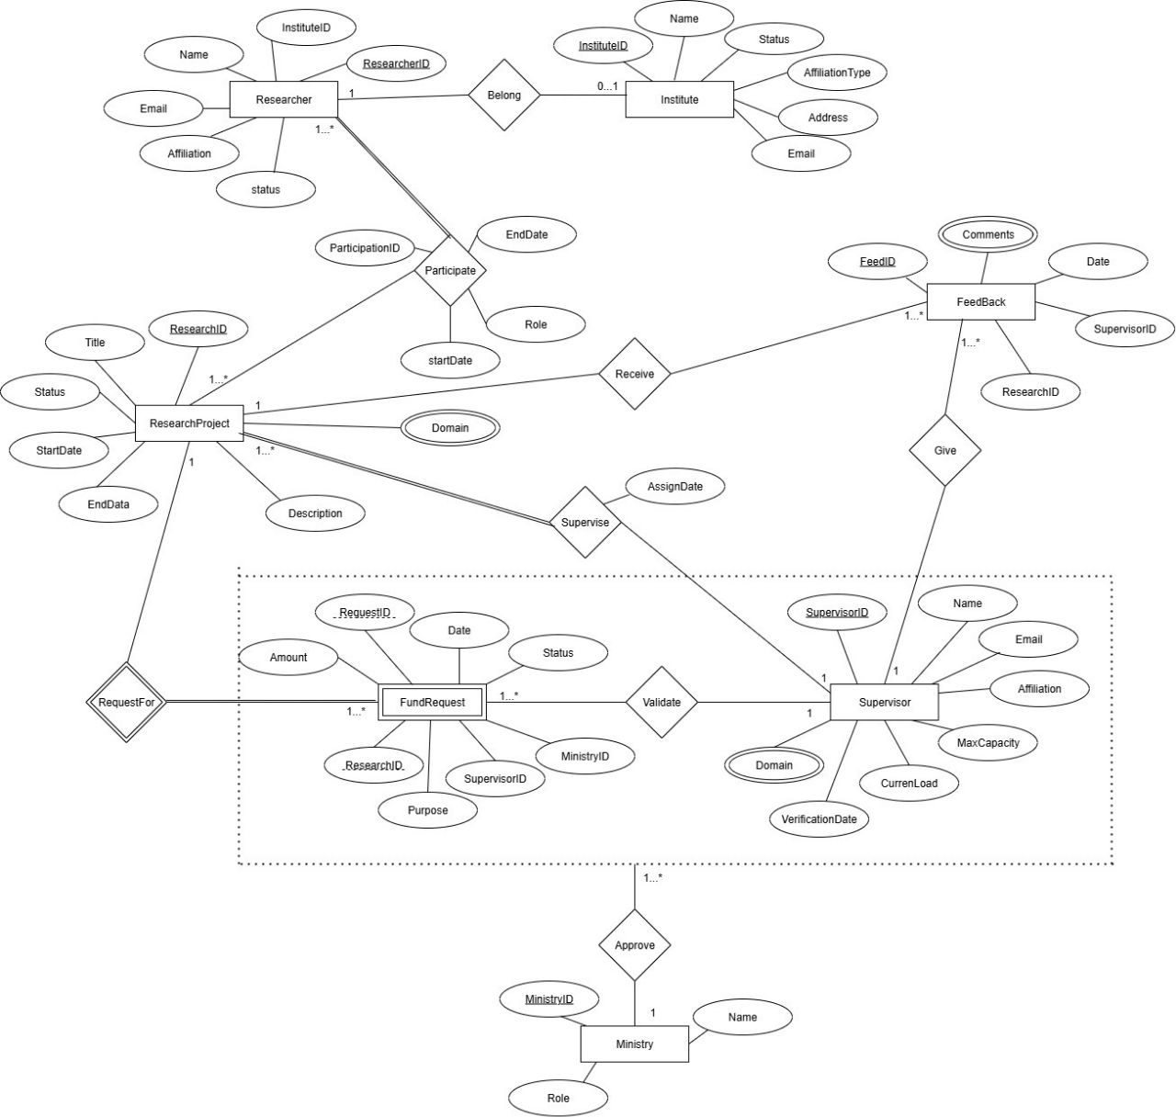

Figure 4.2 ER Diagram

System Feature 3

System Feature 3 (and so on)
Use Case Diagram

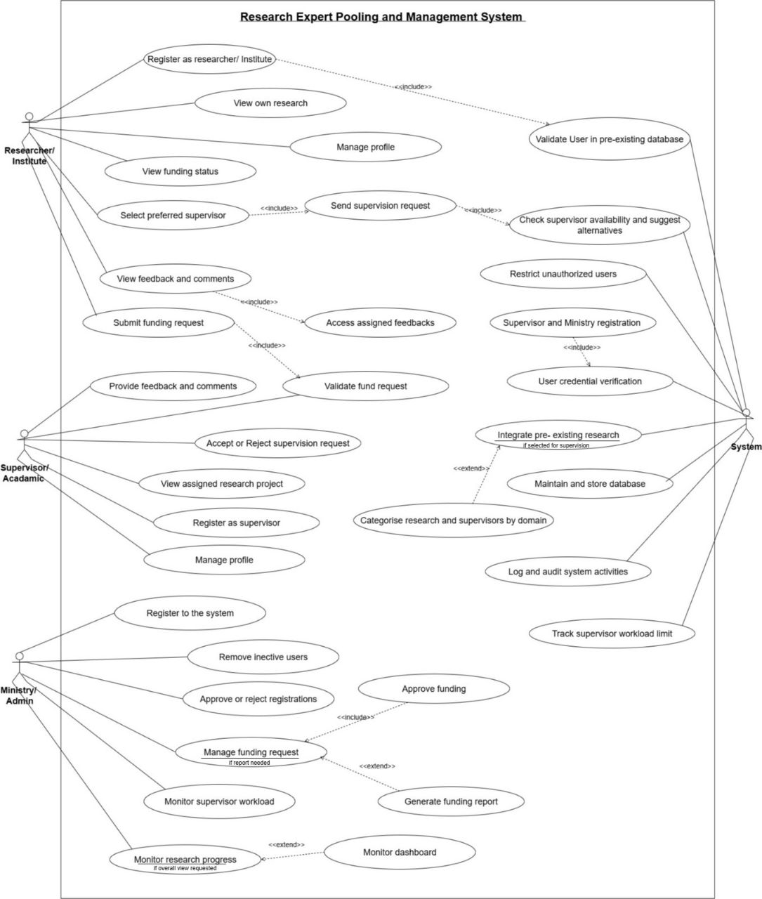
Figure 4.3 Use Case Diagram
Number | 1
Name | Register as Supervisor
Summary | Allows an academic to securely register in the system as a supervisor, ensuring only verified academics join.
Priority | 1
Primary Actor(s) | Supervisor (Academic)
Pre-Condition | The supervisor must be an authorized academic with credentials recognized by the Ministry.
Post-Condition | Supervisor is successfully registered and categorized by domain.
Trigger | Supervisor chooses “Register as Supervisor” from the system interface.
Main Scenario | Step | Actions
 | 1. | Supervisor accesses registration form.
 | 2. | Supervisor enters personal details, academic qualifications, and specialization domain.
 | 3. | System verifies credentials against the existing database.
 | 4. | If valid, the supervisor is registered and categorized by domain.
 | 5. | Confirmation message is displayed.
Extensions | Step | Branching Actions
 | 3a | If credentials are invalid, system rejects registration and prompts re-entry.
 | 4a | If domain not available, supervisor asked to select from approved domains.
Open Issues | What mechanism is used for manual verification if database check fails?

Number | 2
Name | Manage Profile
Summary | Enables supervisors to update or remove their profile information.
Priority | 2
Primary Actor(s) | Supervisor (Academic)
Pre-Condition | Supervisor must already be registered.
Post-Condition | Profile details updated in the database.
Trigger | Supervisor selects “Profile.”
Main Scenario | Step | Actions
 | 1. | Supervisor logs into the system.
 | 2. | Supervisor navigates to profile management.
 | 3. | Supervisor edits profile details (contact info, domain, availability).
 | 4. | System updates and saves changes.
Extensions | Step | Branching Actions
 | 3a | Supervisor chooses to deactivate account, system archives data.
Open Issues | Should historical supervision data remain linked to archived accounts?

Number | 3
Name | Accept or Reject Supervision Request
Summary | Supervisors approve or deny requests from researchers for project supervision.
Priority | 3
Primary Actor(s) | Supervisor (Academic)
Pre-Condition | Supervisor is registered and has capacity within workload limits.
Post-Condition | Request status is updated (accepted or rejected).
Trigger | System notifies supervisor of new supervision request.
Main Scenario | Step | Actions
 | 1. | Supervisor views pending supervision requests.
 | 2. | Supervisor reviews project details.
 | 3. | Supervisor chooses “Accept” or “Reject.”
 | 4. | System updates request status and notify the researcher.
Extensions | Step | Branching Actions
 | 3a | If supervisor workload limit reached, system automatically disables “Accept.”
Open Issues | Can the supervisor later withdraw from an accepted request?

Number | 4
Name | View Assigned Research Project
Summary | Supervisors can view details of the research projects they are supervising.
Priority | 4
Primary Actor(s) | Supervisor (Academic)
Pre-Condition | Supervisor has at least one assigned project.
Post-Condition | Supervisor is aware of assigned research details.
Trigger | Supervisor selects “View Assigned Research Project.”
Main Scenario | Step | Actions
 | 1. | Supervisor logs in.
 | 2. | Supervisor selects “Assigned Projects.”
 | 3. | System displays list of supervised research with details.
Extensions | Step | Branching Actions
 | 3a | If no projects assigned, system displays message “No assigned projects.”
Open Issues | Should supervisors be able to export project details for offline use?

Number | 5
Name | Provide Feedback and Comments
Summary | Supervisors provide structured feedback on assigned projects.
Priority | 5
Primary Actor(s) | Supervisor (Academic)
Pre-Condition | Supervisor is formally assigned to a project.
Post-Condition | Feedback stored in the system and accessible to researcher.
Trigger | Supervisor selects a project and chooses “Feedback.”
Main Scenario | Step | Actions
 | 1. | Supervisor accesses assigned project.
 | 2. | Supervisor selects “Feedback.”
 | 3. | Supervisor enters comments and suggestions.
 | 4. | System saves feedback and notifies researcher.
Extensions | Step | Branching Actions
 | 3a | If supervisor tries to comment on unassigned project, system restricts action.
Open Issues | Should supervisors be able to edit or delete submitted feedback?

Number | 6
Name | Validate Fund Request
Summary | Supervisors review and validate funding requests from researchers before forwarding them to the Ministry.
Priority | 6
Primary Actor(s) | Supervisor (Academic)
Pre-Condition | Researcher must have submitted a funding request.
Post-Condition | Request is either validated and forwarded or rejected.
Trigger | System notifies supervisor of new funding request.
Main Scenario | Step | Actions
 | 1. | Supervisor views pending funding request.
 | 2. | Supervisor reviews research details and justification.
 | 3. | Supervisor either validates or rejects the request.
 | 4. | If validated, request is forwarded to the Ministry.
Extensions | Step | Branching Actions
 | 3a | If justification unclear, supervisor can request additional information.
 | 3b | If project inactive, system rejects automatically.
Open Issues | Should supervisors be able to partially approve funding amounts?

Number | 1
Name | Register as Researcher
Summary | Allows a researcher to register in the system as a researcher, ensuring only verified researchers join.
Priority | 1
Primary Actor(s) | Researcher
Pre-Condition | The researcher must have credentials that recognized by the Ministry.
Post-Condition | Researcher is successfully registered.
Trigger | Supervisor chooses “Register as Researcher ” from the system interface.
Main Scenario | Step | Actions
 | 1. | Researcher accesses registration form.
 | 2. | Researcher enters personal details, academic qualifications, and field.
 | 3. | System validates the researcher’s details against the pre-existing database.
 | 4. | Upon validation, researcher creates a profile and submits registration.
 | 5. | Admin approves or rejects the registration.
Extensions | Step | Branching Actions
 | 3a | If credentials are invalid, system rejects registration and prompts re-entry.
Open Issues | What mechanism is used for manual verification if database check fails?

Number | 2
Name | Selecting a Supervisor
Summary | Allows a researcher to select a preferred supervisor and send a supervision request.
Priority | 2
Primary Actor(s) | Researcher
Pre-Condition | Researcher is registered and logged into the system.
Post-Condition | Researcher is assigned a supervisor or receives alternative suggestions.
Trigger | Researcher selects “Select preferred supervisor” from the system interface.
Main Scenario | Step | Actions
 | 1. | Researcher logs in and views categorized supervisors by domain.
 | 2. | Researcher selects a preferred supervisor and sends a supervision request.
 | 3. | System checks supervisor availability.
 | 4. | Supervisor accepts or rejects the request.
Extensions | Step | Branching Actions
 | 3a | If supervisor is unavailable, system suggests alternative supervisors.
Open Issues | How are alternative supervisors ranked or suggested?

Number | 3
Name | Submitting a funding request.
Summary | Allows a researcher to submit a funding request for their research  Project.
Priority | 3
Primary Actor(s) | Researcher, Supervisor, Ministry
Pre-Condition | Researcher has an assigned supervisor and is logged into the system.
Post-Condition | Funding request is submitted and awaits validation.
Trigger | Researcher selects “Submit funding request” from the system interface.
Main Scenario | Step | Actions
 | 1. | Researcher logs in and navigates to the project section.
 | 2. | Researcher select the project that need a fund.
 | 3. | Researcher submits a funding request with required details.
 | 4. | Assigned supervisor reviews and validates the request.
 | 5. | Ministry approves and allocates funds.
Extensions | Step | Branching Actions
 | 4a | If validation fails, supervisor provides feedback for revision.
Open Issues | What criteria does the Ministry use to approve funding?

Number | 4
Name | Viewing feedback and comments.
Summary | Allows a researcher to review feedback and comments on their research project.
Priority | 5
Primary Actor(s) | Researcher
Pre-Condition | Researcher has an assigned supervisor and ongoing project.
Post-Condition | Researcher receives and can respond to feedback.
Trigger | Researcher selects “View feedback and comments” from the system interface.
Main Scenario | Step | Actions
 | 1.
  Researcher logs in and selects "View feedback and comments".
 | 2. | System displays feedback from the assigned supervisor.
 | 3. | Researcher can provide feedback or comments in response.
Extensions | Step | Branching Actions
 | 2a
  If no feedback exists, system notifies researcher.
Open Issues

Number | 5
Name | Managing Profile
Summary | Allows a researcher to update or manage their profile information.
Priority | 4
Primary Actor(s) | Researcher
Pre-Condition | Researcher is registered and logged into the system.
Post-Condition | Researcher’s profile is updated.
Trigger | Researcher selects “Manage profile” from the system interface.
Main Scenario | Step | Actions
 | 1. | Researcher logs in and selects "Profile".
 | 2. | Researcher updates personal or research details.
 | 3. | Changes are saved and reflected in the system.
 | 4. | Researcher deletes profile by themselves.
Extensions | Step | Branching Actions
 | 2a | If updates are invalid, system prompts for correction.
Open Issues | What restrictions are placed on profile updates?

Number | 1
Name | Approve or Reject Funding Request
Summary | Ministry Officers review validated funding requests from supervisors and make final approval or rejection.
Priority | 1
Primary Actor(s) | Ministry Officer
Pre-Condition | Supervisor has validated the funding request.
Post-Condition | Request status updated in system (approved or rejected).
Trigger | Officer obtains insights for policy-making and funding decisions.
Main Scenario | Step | Actions
 | 1. | Ministry Officer logs into dashboard.
 | 2. | Officer navigates to Funding Requests section.
 | 3. | System displays all pending requests.
 | 4. | Officer reviews request details (amount, justification, supervisor validation)
 | 5. | Officer selects Approve or Reject.
 | 6. | System updates funding records and notifies researcher and supervisor
Extensions | Step | Branching Actions
 | 5a | If budget exceeds threshold → system requires escalation to higher authority
 | 5b | If incomplete justification → system prompts officer to request additional details.
Open Issues | Should officers be allowed to approve partial funding amounts?

Number | 2
Name | Monitor Research Progress
Summary | Ministry Officers monitor research progress across all ongoing projects.
Priority | 2
Primary Actor(s) | Ministry Officer
Pre-Condition | Researcher has submitted periodic progress updates.
Post-Condition | Ministry gains visibility into project timelines and delays.
Trigger | Officer selects Progress Monitoring from dashboard.
Main Scenario | Step | Actions
 | 1. | Officer logs into the system.
 | 2. | Selects Progress Monitoring.
 | 3. | System displays progress percentages and milestones.
 | 4. | Officer applies filters (domain, institute, supervisor).
 | 5. | Officer downloads report if needed.
Extensions | Step | Branching Actions
 | 3a | If no update submitted → system flags project as Awaiting Update.
 | 3b | If delays detected → system highlights project in red.
Open Issues | Should the system auto-escalate overdue projects with critical delays?

Number | 3
Name | Generate Funding & Research Reports
Summary | Ministry generates periodic reports on funding distribution, project performance, and supervisor workloads.
Priority | 3
Primary Actor(s) | Ministry Officer
Pre-Condition | Database contains completed funding and progress records.
Post-Condition | Report is generated and stored in system.
Trigger | Officer requests a report from dashboard.
Main Scenario | Step | Actions
 | 1. | Officer logs into dashboard.
 | 2. | Navigates to Reports section.
 | 3. | Selects type of report (funding, research progress, supervisor allocation).
 | 4. | Chooses date range and format (PDF/Excel).
 | 5. | System generates report.
 |  | Officer downloads or shares report.
Extensions | Step | Branching Actions
 | 3a | If no update submitted → system flags project as Awaiting Update.
 | 3b | If delays detected → system highlights project in red.
Open Issues | Should the system auto-escalate overdue projects with critical delays?

Number | 4
Name | Over see Supervisor Assignments
Summary | Ministry reviews and ensures fair distribution of supervisors across projects.
Priority | 4
Primary Actor(s) | Ministry Officer
Pre-Condition | Researcher has requested supervisor assignment.
Post-Condition | Supervisor assignment approved, modified, or reassigned.
Trigger | Officer accesses Supervisor Requests module.
Main Scenario | Step | Actions
 | 1. | Officer logs into dashboard.
 | 2. | Selects Supervisor Requests.
 | 3. | System lists pending requests with supervisor availability.
 | 4. | Officer approves request OR reassigns to alternate supervisor.
 | 5. | System updates records and sends notifications.
Extensions | Step | Branching Actions
 | 4a | If requested supervisor unavailable → system suggests alternatives.
 | 4b | If workload imbalance detected → system alerts officer.
Open Issues | Should ministry officers have authority to override researcher’s preferred supervisor choice?

Number | 5
Name | Access Analytics Dashboard
Summary | Provides ministry officers with visual analytics on national research activities.
Priority | 5
Primary Actor(s) | Ministry Officer
Pre-Condition | Active data available in system.
Post-Condition | Officer obtains insights for policy-making and funding decisions.
Trigger | Officer opens Analytics Dashboard..
Main Scenario | Step | Actions
 | 1. | Officer logs into system.
 | 2. | Selects Analytics.
 | 3. | Dashboard displays KPIs: active projects, funding utilization, supervisor workload.
 | 4. | Officer views domain-wise breakdown.
 | 5. | Officer exports dashboard charts.
Extensions | Step | Branching Actions
 | 3a | If data sync with external DB fails → warning message shown.
 | 3b | Officer customizes dashboard filters (domain, year, institution)
Open Issues | Should officers be able to share dashboards externally
Activity Diagrams

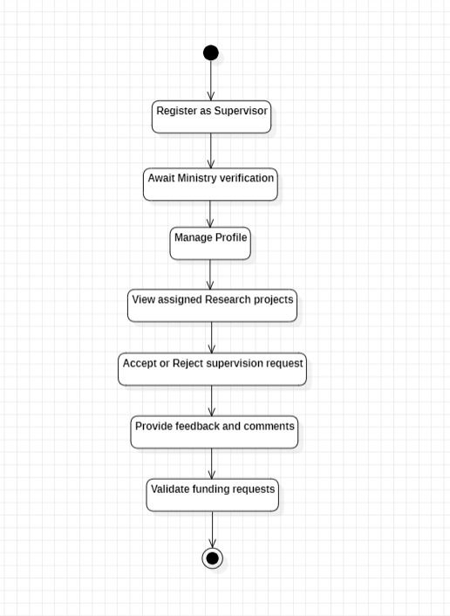

Figure 4.4 Activity Diagram for Supervisor

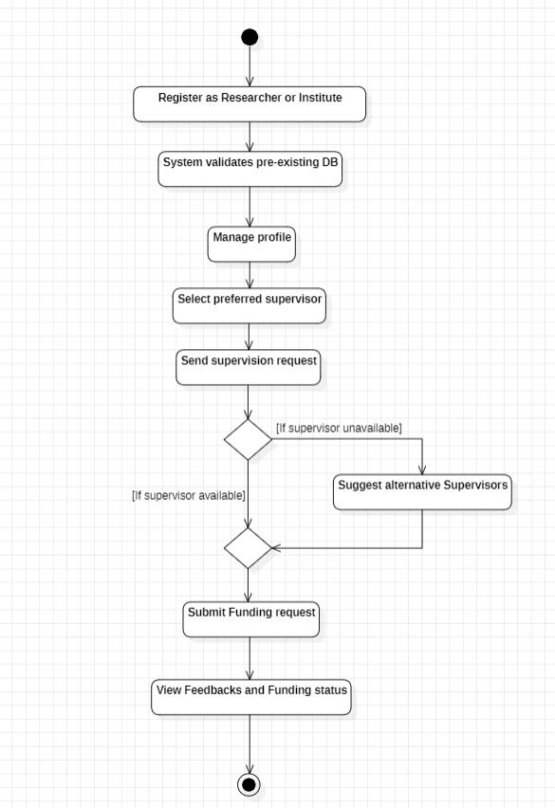

Figure 4.5 Activity Diagram for Researcher

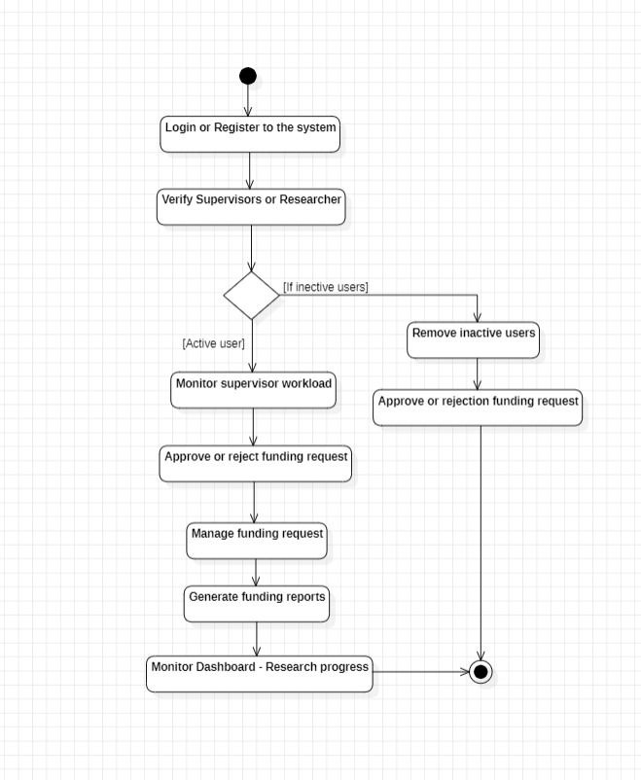
Figure 4.6 Activity Diagram for Ministry

Class Diagram

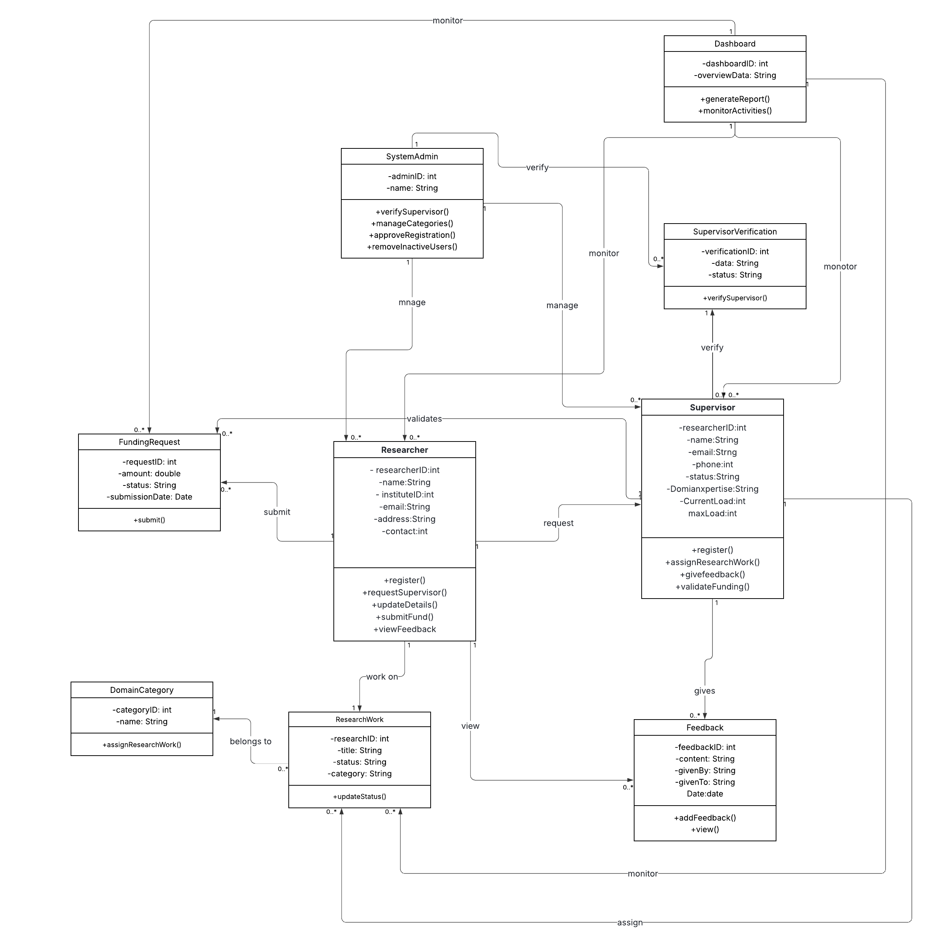
Figure 4.7 Class Diagram for system

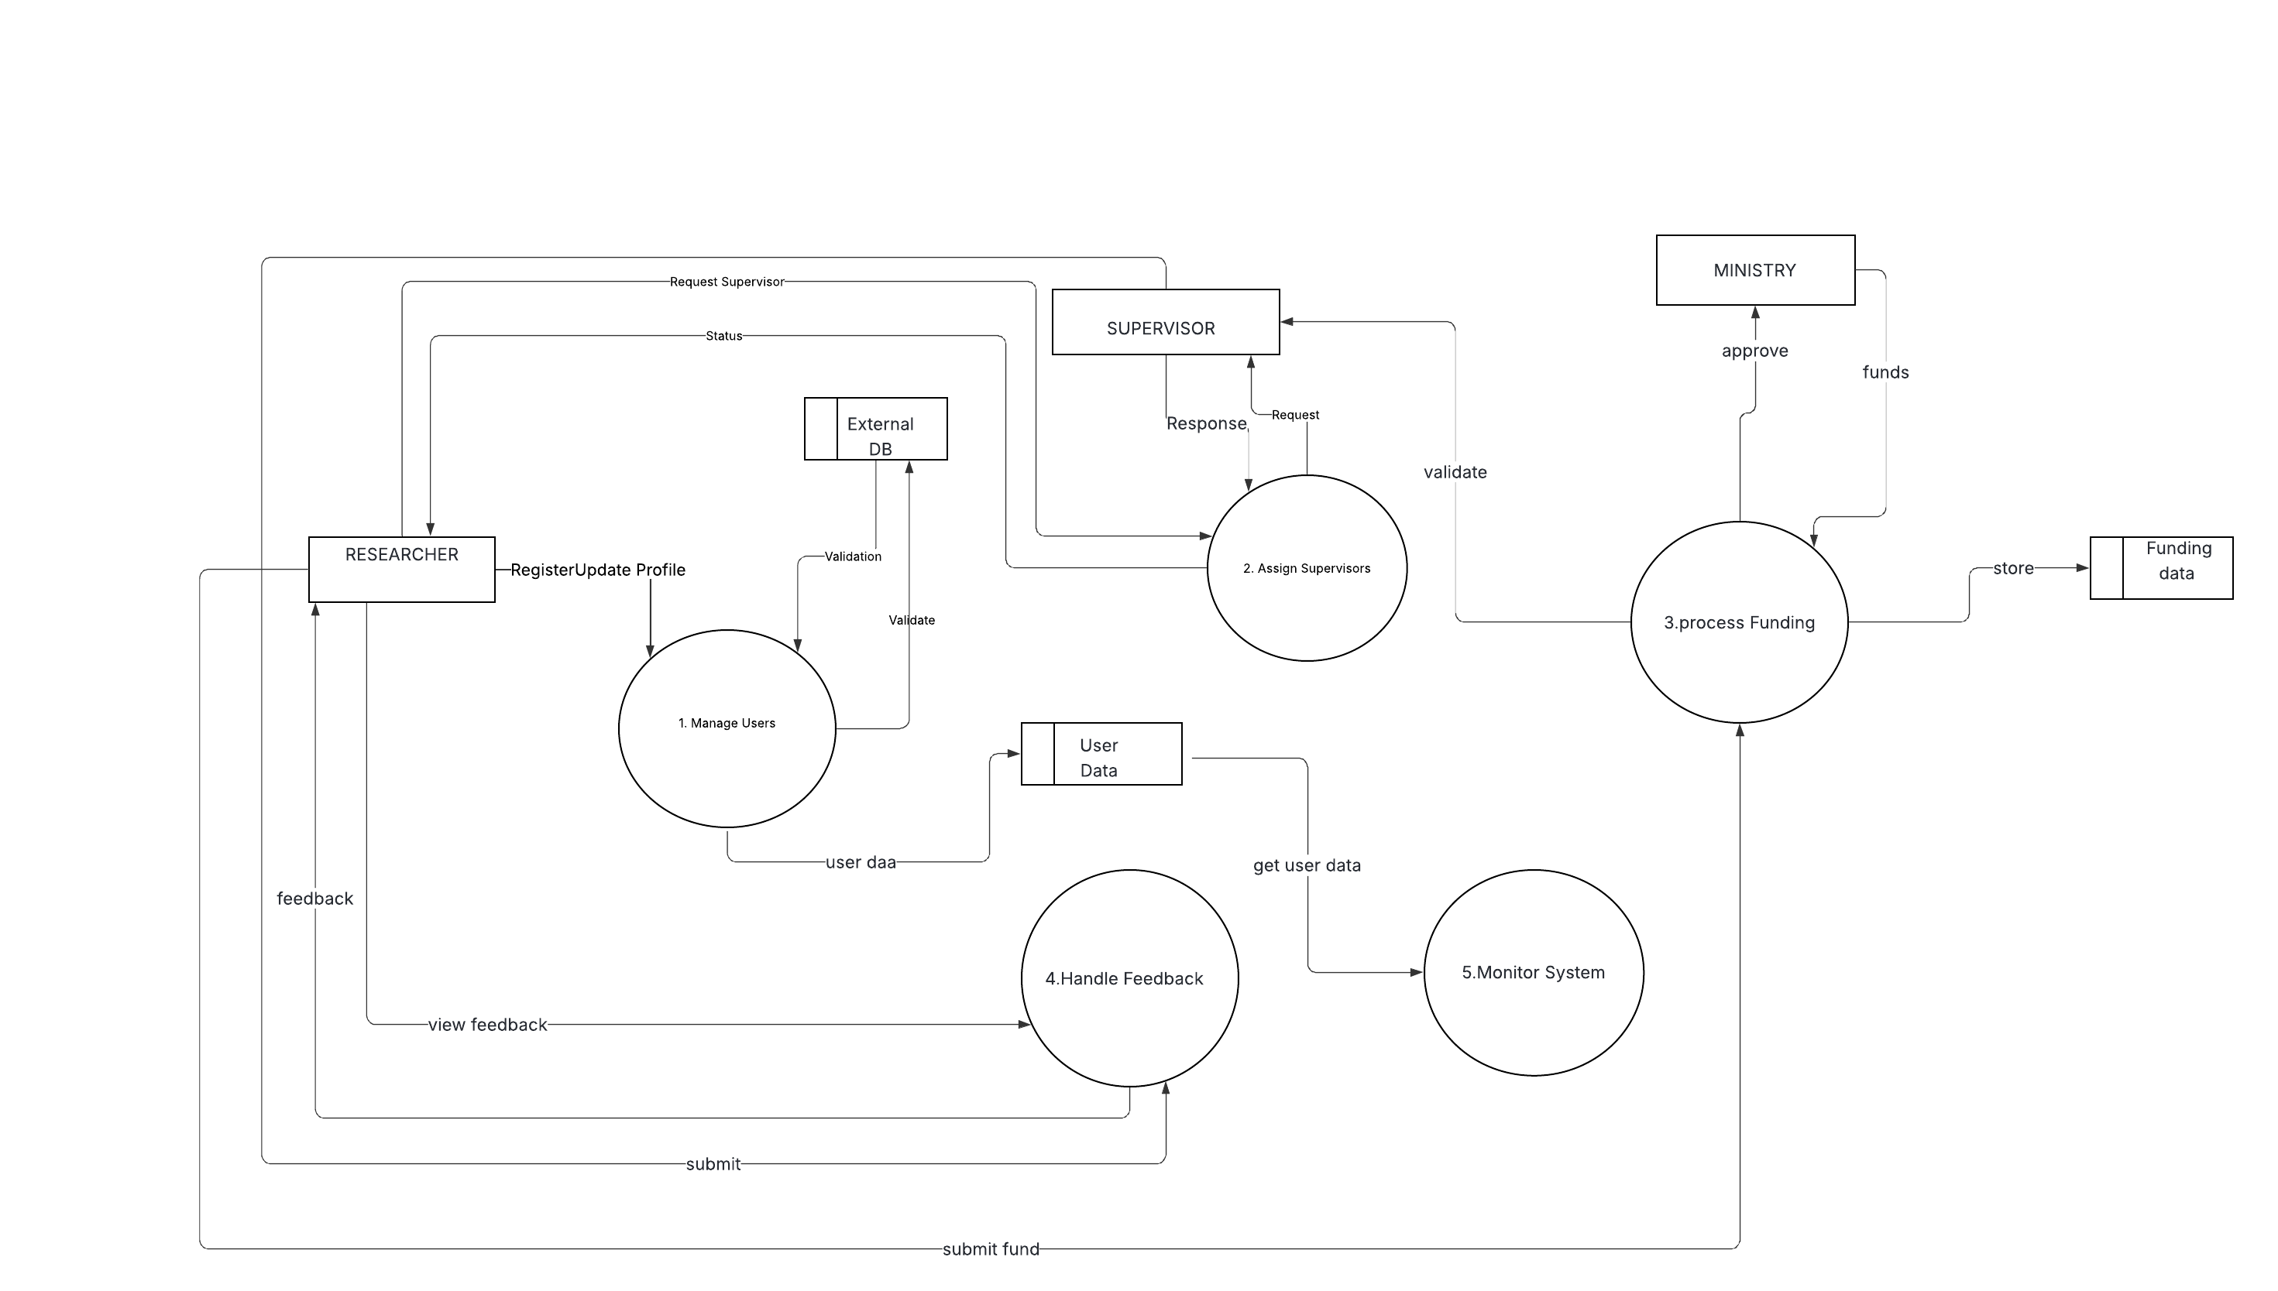
Figure 4.8 Level 1 DFD Diagram

Other Nonfunctional Requirements

Performance Requirements
NFR 1 | System Availability
Description | The system must be available 99.9% of the time, excluding scheduled maintenance windows (e.g., 2 hours monthly), to ensure continuous access for all users.

NFR 2 | Response Time
Description | The system must respond to user requests within 2 seconds under normal load (up to 500 concurrent users) and within 5 seconds under peak load (up to 1,000 concurrent users).

NFR 3 | Database Performance
Description | The system must handle 10,000 database queries per minute under normal load, scaling to 20,000 queries per minute under peak load, with a latency of less than 500 milliseconds per query.

NFR 4 | Scalability
Description | The system must support up to 2,000 concurrent users with a linear increase in response time (no more than 10% degradation) as load increases from normal to peak.

NFR 5 | Failover and Recovery
Description | In case of failure, the system must recover and restore services within 30 seconds, with no data loss for transactions in progress.

NFR 6 | Authentication and Access Controls
Description | Implement multi-factor authentication (MFA) for all users (researchers, supervisors, admins/Ministry).

Safety Requirements

NFR 7 | Data Encryption
Description | Sensitive fields (e.g., personal details, funding amounts) must be tokenized or anonymized where possible.

NFR 8 | Backup and Recovery
Description | System must allow restoration within 4 hours of a failure, with no data loss for transactions in the last 24 hours.

NFR 9 | Ethical Safeguards
Description | Integrate checks for research ethics compliance during registration and funding requests (e.g., require ethics approval documentation for projects involving human subjects).System must flag projects in sensitive domains (e.g., health) for mandatory review by ethics committees.

Security Requirements
NFR 10 | Multi-Factor Authentication (MFA)
Description | All users (researchers, supervisors, Ministry admins) must use MFA for login, combining password.

NFR 11 | Password Policies:
Description | Enforce strong passwords (minimum 12 characters, complexity rules) with regular changes (every 90 days) and lockouts after 5 failed attempts.

NFR 12 | Session Management
Description | Sessions must timeout after 15 minutes of inactivity, with secure token-based authentication (e.g., JWT) for API calls.

External Policies and Regulations
- Personal Data Protection Act (PDPA) No. 9 of 2022
- Minimum Information Security Standards (MISS) by SLCERT
- Online Safety Act

Software Quality Attributes

Availability
Beyond the 99.9% uptime specified in performance requirements, the system must achieve 99.99% availability during peak research seasons (e.g., January-March for grant cycles), with mean time to recovery (MTTR) from outages under 5 minutes.

Correctness
All core functions (e.g., supervisor assignment, funding validation) must produce accurate results in 100% of test cases, with no more than 0.1% error rate in production as measured by user-reported issues.

Flexibility
The system must allow configuration of workflow parameters (e.g., supervisor maxLoad) via admin interfaces without code changes, supporting at least 10 customizable fields per entity (e.g., Researcher, FundingRequest).

Robustness
The system must gracefully handle invalid inputs (e.g., malformed funding requests) by rejecting them with error messages, recovering from 99% of edge cases (e.g., network interruptions) without data loss.

Usability
The interface must achieve a System Usability Scale (SUS) score of at least 85/100, with task completion times under 2 minutes for common actions (e.g., submitting a funding request), and support accessibility standards (WCAG 2.1 Level AA).

Business Rules
Researcher Registration: Only researchers or institutions with pre-existing credentials in the Ministry's database can register. Unauthorized individuals are restricted from accessing the registration function to maintain credibility and security.
Supervisor Registration: Supervisors must undergo verification by the Admin before gaining access. Only verified academics in specialized fields (e.g., Health, Engineering) can register and be categorized by domain.
Profile Management: Researchers and Supervisors can manage their own profiles (update details or request removal) at any time, but changes must be logged. Admins can remove inactive users after a period of inactivity (e.g., 6 months) to keep the platform reliable.
Supervisor Selection and Request: Researchers can select preferred Supervisors from the same domain and send requests only if logged in and registered. If a Supervisor's workload limit is reached, the system suggests alternatives; Supervisors can accept or reject requests based on availability.
Feedback Provision: Supervisors can view all research works in their domain but provide feedback and comments only on formally assigned projects. Researchers can view and respond to feedback on their own projects.
Funding Request Workflow: Researchers can submit funding requests only for assigned projects. Supervisors validate requests for their assigned researchers. Admins (Ministry) approve and allocate funds after validation, with oversight of all requests.
Workload Enforcement: Supervisors are marked as unavailable once their maximum supervision capacity is reached; no new requests can be assigned until capacity frees up.
Monitoring and Oversight: Admins have full access to a centralized dashboard for monitoring research activities, supervisor workloads, registrations, and funding allocations at all times. They can generate reports and audit logs but cannot directly intervene in research content without justification.
User Restrictions: Unauthorized users are restricted from all functions except public information views (if any). Inactive users (no login for 6 months) can be removed by Admins to maintain an active platform.
Ethical and Compliance Checks: For sensitive domains (e.g., Health), Supervisors and Admins must verify ethics approvals before assigning or funding projects.

Other Requirements

Database Requirements
The system must use a relational database management system (RDBMS) such as PostgreSQL or MySQL, with schema design based on the class diagram (e.g., tables for Researcher, Supervisor, ResearchWork, FundingRequest, Feedback). Data must be normalized to at least 3NF to minimize redundancy and ensure integrity.

Legal Requirements
Align with University Grants Commission (UGC) guidelines for higher education funding and National Research Council (NRC) requirements for investigator-driven grants, including eligibility (e.g., MPhil degree for applicants) and prior approvals for foreign grants.

Appendix A: Glossary
- API (Application Programming Interface): A set of rules and tools that allows different software applications to communicate with each other, used in the system for integration with the national research database.
- Admin: Refers to Ministry officers or system administrators responsible for system governance, user management, funding approvals, and oversight via the centralized dashboard.
- Domain: A field of expertise or research area (e.g., Health, Science, Engineering) used to categorize supervisors and research projects within the system.
- Funding Request: A formalized request submitted by a researcher for financial support for a research project, requiring validation by a supervisor and approval by the Ministry.
- IEEE 830-1998: An IEEE standard for Software Requirements Specifications, used as the structural guideline for this SRS document.
- JWT (JSON Web Token): A secure token-based authentication method used for API calls and session management in the system.
- KPI (Key Performance Indicator): Metrics displayed on the Ministry dashboard to monitor system status, such as active projects, pending requests, and funds allocated.
- MFA (Multi-Factor Authentication): A security mechanism requiring multiple forms of verification (e.g., password and email code) for user login.
- Ministry: The Ministry of Science and Technology in Sri Lanka, the primary stakeholder overseeing the Research Expert Pooling and Management System.
- National Research Database: An existing external database containing pre-registered researcher and project data, used for validating registrations in the system.
- PDPA (Personal Data Protection Act): Sri Lankan legislation (No. 9 of 2022) governing the protection of personal data, which the system must comply with.
- PostgreSQL: An open-source relational database management system used for storing system data, such as user profiles, research works, and funding records.
- REPM System (Research Expert Pooling and Management System): The web-based application developed for the Ministry to coordinate and manage national research activities.
- Researcher: An individual or representative of a research institute registered in the system to submit supervision requests, funding requests, and manage research profiles.
- Role-Based Access Control (RBAC): A security model where user permissions are determined by their role (e.g., Researcher, Supervisor, Ministry/Admin) in the system.
- SRS (Software Requirements Specification): A document that defines the functional and non-functional requirements, scope, and constraints of the REPM System, following the IEEE 830-1998 standard.
- Supervisor: A verified academic responsible for supervising research projects, validating funding requests, and providing feedback within their domain of expertise.
- System Usability Scale (SUS): A standardized metric used to evaluate the usability of the system’s interface, targeting a score of at least 85/100.
- UML (Unified Modeling Language): A standardized modeling language used for creating diagrams (e.g., use case, class, activity) to represent system design and functionality.
- WCAG 2.1 (Web Content Accessibility Guidelines): International standards for web accessibility, with the system required to meet Level AA compliance for inclusivity.

Appendix B: Analysis Models
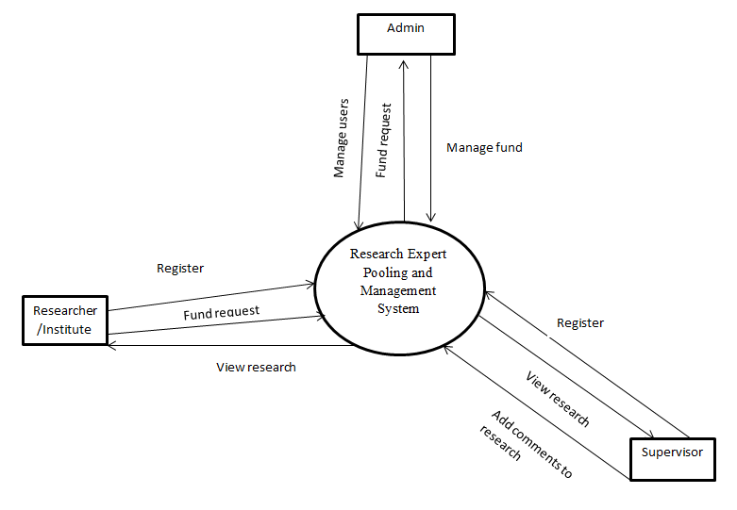

Figure 0.9 Context Diagram

Appendix C: To Be Determined List

